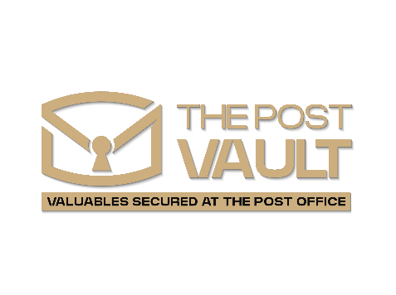

Safe Deposit Boxes

Safe deposit boxes provide a secure, private space for storing important documents and valuables. Available in a range of sizes to suit your needs.

**Important Information Summary**

**Account Features**

* Keep your valuables secure in a highly protected environment.
* Access your safe deposit box during store opening hours.
* Available to Post Vault Personal Current and Cash Account holders aged 18 and over.
* Also available to Post Vault Business Current Account customers.

This document summarises the important features of The Post Vault Safe Deposit Box. It should be read carefully

together with The Post Vault Safe Deposit Box Terms and Conditions (the ‘Terms and Conditions’). If there is anything you do not understand please ask any The Post Vault Customer Service Representative. These details are correct as of 30 June 2025.

|  |  |  |  |  |  |
| --- | --- | --- | --- | --- | --- |
| KEY PRODUCT INFORMATION | | | | | |
| **Safe Deposit Box price list**  You can choose to pay for your Safe Deposit Box monthly or annually, with fees payable in advance.  The price list below outlines the standard charges.  A 10% discount may be available for the first year from the date of box rental. | | | | | |
| **Name of Box** | **Box Size mm** (H x W x D) | **Annual Fee** (inc. VAT) | | **Monthly Fee** (inc. VAT) | |
|  |  | **Standard price** | **10% Discount** | **Standard price** | **10% Discount** |
| **Size A** | 60 x 165 x 540 | £129 each | £116.10 each | £10.75 each | £9.58 each |
| **Size B** | 120 x 165 x 540 | £199 each | £179.10 each | £16.58 each | £14.93 each |
| **Size C** | 60 x 235 x 540 | £229 each | £206.10 each | £19.08 each | £17.18 each |
| **Size D** | 110 x 235 x 540 | £277 each | £249.30 each | £23.08 each | £20.78 each |
| NB: These prices are the standard price for a Safe Deposit Box. The 10% discount is only available if eligible.     * The 10% discount is only available when opening a new Post Vault Safe Deposit Box. * Existing customers opening a second box or upgrading to a larger size are eligible for the discount on the new or upgraded box, subject to availability. * Customers who have closed a box of the same size within the past month are not eligible for the discount. * A maximum of two discounted boxes is allowed per customer.   Access   * Two copies of a unique key for each Safe Deposit Box • Secure environment, locked in a vault * Thirty access available during Store opening hours • Safe Deposit Box viewing room available in every Store | | | | | |
| Additional charges and fees  Missed renewal payment: £20  Early closure fee. Minimum term of 6 months applies: £50  Forced box opening (drilling and lock replacement) Weekdays: £200 • Saturdays (limited store location): £300  Lost/stolen single key: £100 | | | | | |



Safe Deposit Box (continued)

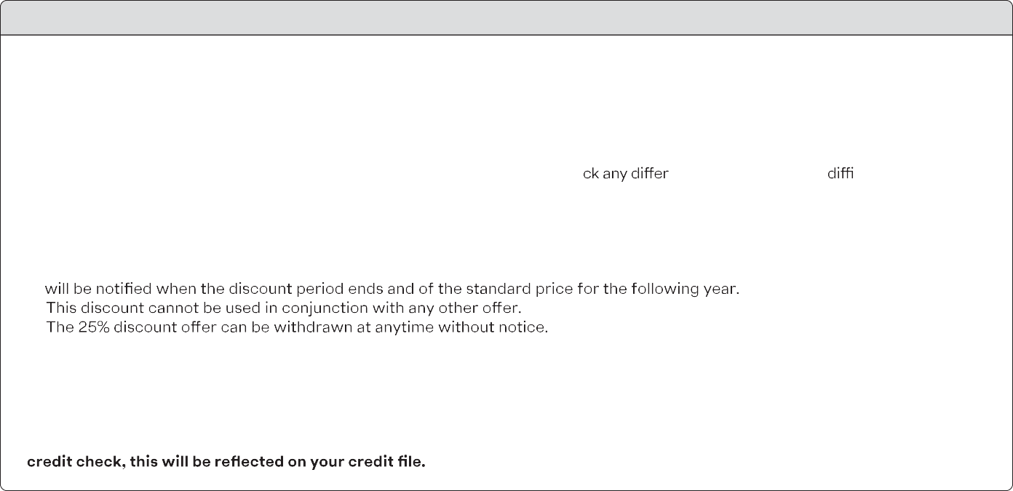

THINGS YOU SHOULD CONSIDER

* You must only keep items that belong to you in your Safe Deposit Box.
* If you lose your Safe Deposit Box key we will change the lock toy our box and give you a new key. We will charge a fee to cover the cost of replacing the lock. The fee is payable on receipt of the new key. If you require a second key, a further fee is payable.
* There are certain items which you must not keep in your box, such as cash, chemicals, knives and plants – please see Term 3 of the Terms and Conditions for more details.
* Your fees must be paid on time in order to access your Safe Deposit Box. If we have not obtained payment from you after 120 days, we may open your box, sell the contents to pay our fees and costs and pay you ba ence. If you are having culties

making payments please contact us as soon as possible.

* You should consider whether you need to insure the items. Keeping valuables in a Safe Deposit Box should not be seen as insurance of the valuables.
* The 25% discount only applies for one year from the date of the new Safe Deposit Box opening. Subject to availability.
* After the one year discounted period, the Safe Deposit Box renewal price will revert to the standard box price at that time. You
* Find our latest store hours at The Post Vault online.co.uk/store-locator/latest-store-opening-hours/

**Opening a Safe Deposit Box requires a customer to already hold a The Post Vault cash account, or a The Post Vault personal or business current account. If you do not have one, you will be required to open a cash or current account at the same time.**

**These accounts are subject to their own terms and conditions. Before taking out a cash or current account you should carefully consider which type of account is suitable for your needs. Please Note: if a current account application is declined following a**